**The Effects of Privacy Protection on Forecast Accuracy**

Speaker: Cameron Bale, Ph.D. Student, LeBow College of Business, Drexel University

Coauthors: Matthew J. Schneider, Jinwook Lee

Forecasts generated using protected time series change significantly from those using the original time series. While prior experiments have demonstrated severe degradations in forecast accuracy from a VAR model applied to differentially private time series, little is known about how privacy protection affects other forecasting models. We measure the effects of several data protection methods (top and bottom coding, additive noise, differential privacy, and cluster-based swapping) on both simple and complex forecasting models. We find that data protection degrades forecast accuracy the majority of the time regardless of forecast horizon. Surprisingly, when the time series are protected with differential privacy or additive noise, we find that exponential smoothing models have better accuracy than LGBM models for all forecast horizons. We investigate the reasons behind these results and offer guidance for practitioners in selecting a forecast model for privacy protected time series data.

**Introduction/Literature Review**

1. Effect of data protection on forecast accuracy is understudied
   1. ~~Forecasting is popular in a variety of fields, such as consumer analytics, renewable energy and power industries, and census tracking. Privacy sensitive data such as UGC which have been shown to reduce forecast errors (Boone et al., 2019).~~
   2. ~~However, legislation such as GDPR, California Consumer Privacy Act, California Privacy Rights Act, Colorado Privacy Act, Virginia Consumer Data Protection Act, and the Utah Consumer Privacy Act encourage organizations to protect time series data.~~
   3. ~~Recent research found that the strongest form of privacy protection (differential privacy) degrades forecast accuracy of VAR models, but accuracy can improve when data owners collaborate and share their measurement data instead (Gonçalves et al., 2021).~~
   4. ~~Other studies (Abowd et al., 2012; Nin & Torra, 2009) found that noise infusion had a small effect on auto-correlation coefficients and that the protected data was unbiased on average, while protection using~~ *~~k~~*~~-anonymity produced large changes in the means, autocorrelation functions, and forecast accuracy of protected time series.~~
   5. ~~In this paper, we care about how multiple forecasting models, from simple to complex, perform when trained on protected data.~~
   6. ~~Need to discuss how we assume that a data recipient does not have knowledge of how the data was protected.~~
2. ~~Forecasts based on protected data are closely related to the judgmental forecasting (Petropoulos et al. 2021, sections 2.11.2 and 3.7.3)~~
   1. ~~First, different forms of data protection produce multiple data points which have a different forecast. This differs from judgmental forecasting having multiple forecasts from a single data point.~~
   2. ~~Second, similar to Fildes et al. (2009) we focus on cases where the forecast based on the protected data is improving or degrading forecast accuracy.~~
   3. ~~Third, we require insights to minimize accuracy. Involves analyzing multiple data protection methods and forecasting models. We measure how data protection alters time series characteristics such as levels and trends.~~
3. ~~How data protection changes time series characteristics and translate to changes in forecast accuracy~~
   1. ~~Volatility of adjustment~~
      1. ~~Judgmental adjustments can increase accuracy when based on reliable information, but information with low diagnosticity can damage forecast accuracy (Fildes et al., 2009, 2019).~~
      2. ~~When accuracy did improve, increases in accuracy from adjustments to forecasts were greater for low volatility series which are easier to forecast (Fildes et al., 2009). We will examine the changes in forecast accuracy due to data protection with low diagnosticity (random noise).~~
      3. ~~Adjusting for outliers, mainly those close to the forecast origin (similar to data protection), can increase forecast accuracy (Chen & Liu, 1993). Since top and bottom coding will reduce the effect of outliers on forecasts, we will examine how forecast accuracy changes for series with outliers.~~
4. ~~How changes to forecasts are related to changes in forecast accuracy.~~
   1. ~~Direction of adjustment.~~
      1. ~~Both negative and positive adjustments increase accuracy (positive gives only marginal increase), overall accuracy increased by 10% (Davydenko & Fildes, 2013). Negative adjustments tended to reduce bias, while positive adjustments maintained bias magnitude or exacerbated it (Fildes et al., 2009).~~
      2. ~~For judgmental forecasts, the direction of adjustment is chosen with the intent of improving the forecast – under data protection, direction is a result of the protection method, without regard to the effect on forecasts. We will measure the proportions of forecasts that are adjusted positively and negatively, the accuracy of the forecasts for each adjustment direction, and the resulting changes in forecast bias.~~
   2. ~~Size of adjustment.~~
      1. ~~(Fildes et al., 2009) found that the size of adjustments was positively associated with the size of accuracy improvements. One explanation given is that an adjuster who is more confident will make a larger adjustment, which improves accuracy when based on reliable information.~~
      2. ~~Under data protection, the adjustment size will be determined by the forecasting models’ responses to the data protection, which are likely related to the strength of protection.~~
      3. ~~We will measure the strength of protection by the magnitude of the adjustment (P_t-A_t), how this relates to the size of adjustments in the forecasts based on protected data, and whether adjustment size is related to the change in forecast accuracy from data protection. We need to be careful with large positive adjustments versus large negative adjustments.~~
5. Extant studies on data privacy and forecasting.
   1. (Goncalves et al., 2021) found that data owners have a monetary incentive to share their data, but may be discouraged from doing so due to privacy concerns over sharing data with a central party. Transfer learning (Wellens et al., 2021) is designed to train models on sensitive data and transferred themselves, which can overcome privacy barriers or regulations. Our work would help answer how forecast accuracy would be affected if the data owners applied data protection methods prior to sharing their data using single protected dataset, not shared models which are computationally expensive.
   2. Differential privacy is the most popular data protection method applied to time series, see (Imtiaz et al., 2020; Liyue Fan & Li Xiong, 2014) for examples. An interesting result from (Imtiaz et al., 2020) is that differentially privacy data did not always produce worse forecast accuracy when forecasting individuals’ health data using a recurrent neural network. The reason is adding random Gaussian noise to time series is a technique to prevent overfitting when forecasting with neural networks (Hewamalage et al., 2021).
   3. Data integrity attacks (Luo et al., 2018) add random noise to data and have also been found to degrade accuracy of multiple linear regression, artificial neural network, support vector regression, and fuzzy interaction regression models. Support vector regression was most robust and performed the best under the data integrity attacks.
   4. We will explore whether data protection using differential privacy improve forecast accuracy for neural networks and simpler models alike and underlying reasons *why* the forecast accuracy changed.
6. Data protection literature review
   1. Additive/Multiplicative noise is similar to differential privacy in that random noise is infused into the data, but there are no theoretical privacy guarantees. (Luo et al., 2018) use multiplicative random noise to simulate a data integrity attack in load forecasting time series. (Abowd et al., 2012) protect individual series in QWI data using a single multiplicative noise factor that is applied to all time periods.
   2. *K*-anonymity is a definition where every record (or time series) in a dataset is identical to at least *k*-1 other records (Sweeney, 2002).   
      (Nin & Torra, 2009) evaluate the change in forecast accuracies of simple exponential smoothing, double exponential smoothing, linear regression, multiple linear regression, and polynomial regression applied to *k*-anonymized data and found significant reductions in forecast accuracy across all five models even for *k*=2, they do not provide a comparison between models or additional data protection methods.
   3. (Crimi & Eddy, 2014) study the effect of top coding the Census’ Public Use Microdata Samples on analyses of interest. They find that the sample correlation between two variables is shrunk towards zero when one or both of the variables are top coded. We seek to explore whether these changing correlational structures affect multivariate forecasting model performance.
7. Our contributions (to be decided after results)
   1. An empirical comparison of forecasting models’ accuracies based on protected data. We seek to discover whether simple or complex models forecast more accurately after data protection.
   2. We apply forecasting models to the M3 monthly micro data. In addition, we use time series characteristics, such as spectral entropy, to explain the changes in model performance post-data protection.

**Empirical Application (or Data/Model/Results sections)**

1. **Data** – M3 monthly Micro
   1. ~~Describe data and the original competition. 474 time series, min/max~~
   2. ~~Complex models perform well on unprotected data (Cite literature here)~~
   3. ~~Models that explicitly model trend and seasonality performed the best (Kang et al., 2017)~~
   4. Measure levels/trends/seasonalities on the unprotected data. Measure all time series characteristics, AR(1) parameters, frequency (monthly), etc.
   5. *We could benefit from a better data set for managerial implications*
2. **Methods** – ~~If we are using k-means shuffling, we can have this here~~
   1. ~~Table including data protection methods - - Differential privacy, top/bottom coding, additive/multiplicative noise~~
   2. Specify how time series characteristics are used to decide which time series are most similar
   3. Include a proof or two showing why it should improve accuracy
3. **Models** 
   1. Selection of Forecasting Models
      1. Popular models found in R, Python and/or serving as benchmarks in forecasting competitions. These models show how forecast accuracy would change for ‘non-expert’ users.
      2. SES, DES, TES, ARIMA, LGBM (univariate), VAR, LGBM (multivariate), RNN (LSTM cells)
      3. Prophet (Facebook), Greykite (LinkedIn), NeuralProphet
      4. Discuss briefly about tuning parameters selected/etc. – this is not the focus of the paper.
4. **Analysis Framework**
   1. Forecasting Process
      1. Fixed origin forecasting with two horizon lengths: 1-step and 18-step (18 step was used for monthly data in M3 (Makridakis & Hibon, 2000))
      2. Describe process, train, test, validation sets
         1. Obtain original series $Y$**,** Create protected series $\tilde{Y}$
         2. Extract time series characteristics from $Y$ and $\tilde{Y}$
         3. Train each forecasting model on $Y$ and $\tilde{Y}$
         4. Generate forecasts for $Y$ and $\tilde{Y}$
   2. Measure forecast accuracies as categorized by the intro/lit review
      1. Overall – for all time series
         1. MAE for directly comparing model accuracy.
         2. AvgRelMAE (scale independent, robust to outliers, easily interpretable) for comparing accuracy change after data protection: $AvgRelMAE=exp\left[\frac{1}{\sum_{i=1}^{m}{n_{i}}}\sum_{i=1}^{m}{n_{i}ln}r_{i}\right]$, where $r_{i}=\frac{MAE_{i}^{p}}{MAE_{i}^{o}}$, and where $p$ denotes protected, $o$ denotes original, $n_{i}$ is the number of adjusted forecasts for series $i$ and $m$ is the number of series. AvgRelMAE < 1 (> 1) indicates increased (damaged) accuracy on average. Average percentage improvement in MAE of forecasts is (1 – AvgRelMAE) $×$ 100. 5% trim on AvgRelMAE is recommended (Davydenko & Fildes, 2013).
      2. Explain why accuracies are different using time series features and visualize using instance space (PCA applied to extracted features) (Hewamalage et al., 2022; Kang et al., 2017).
         1. Examine distributions of time series characteristics (e.g., seasonality, trend) before and after data protection to explain *why* models had increases/damages in accuracy.
         2. We measure spectral entropy, strength of trend and seasonality, and the first order auto-correlation parameter. We perform PCA on the $N×4$ matrix of these features, where $N$ is the number of time series. Features are standardized first.
         3. Spectral entropy (forecastability/diagnosticity).
            1. Relate to 3.1.1 and 3.1.2.
         4. Coefficient of variation (directly measure volatility) (Fildes et al., 2009).
            1. Relate to 3.1.1 and 3.1.2.
         5. Strength of trend and seasonality.
         6. First order autocorrelation.
         7. Optimal box-cox transformation parameter.
         8. Outliers – how accuracy changes for series with outliers and how that depends on distance of outliers to forecast origin
            1. Relate to 3.1.3.
      3. Direction - Proportion of positive/negative adjusted forecasts. Change in accuracy (AvgRelMAE) for positive and negative adjusted forecasts. Bias (mean of forecast errors) for positive and negative adjusted forecasts.
         1. Relate to 4.1.2 and table 3 below.
      4. Magnitude
         1. Measure magnitude of data adjustment ||
         2. Measure size of adjustment in forecasts: Size= 100 ×|Protected-Original|\/Original (Fildes et al., 2009).
         3. Measure relationship between size of adjustment and change in forecast accuracy.
         4. Look at this overall and split into positive adjustments and negative adjustments.
   3. ~~Complexity – relationship between complexity and forecast accuracy before and after data protection. Measure complexity using Kolmogorov complexity as described by (Hewamalage et al., 2022)~~
      1. ~~Train Model 🡪 Save Model (coefficients, objective functions, etc.) 🡪 Gzip Compressed Model 🡪 Approximate Kolmogorov Complexity using size of the compressed model on disk.~~
      2. ~~Regress Accuracy ~ Complexity. To make conclusive statements on how model complexity affects accuracy using protected data. Cite prior literature for the unprotected data (complex models forecast more accurately!)~~

**Results**

**We need tables that forecasting readers want to see here. You can have the detailed ones as well, but think hard about overall metrics to display based on the intro/lit reviews. These are usually found in other research papers but you need to be creative too in order to put ones in the results subsections above.**

1. Comparison with original M3 results using sMAPE.
   1. One challenge is results in other work are not reported for only M3 monthly micro, they report results for the full M3 monthly data.
   2. I downloaded the forecasts from the original M3 competition and calculated their errors manually for the monthly Micro data.
   3. $h = 1$, strong privacy protection.

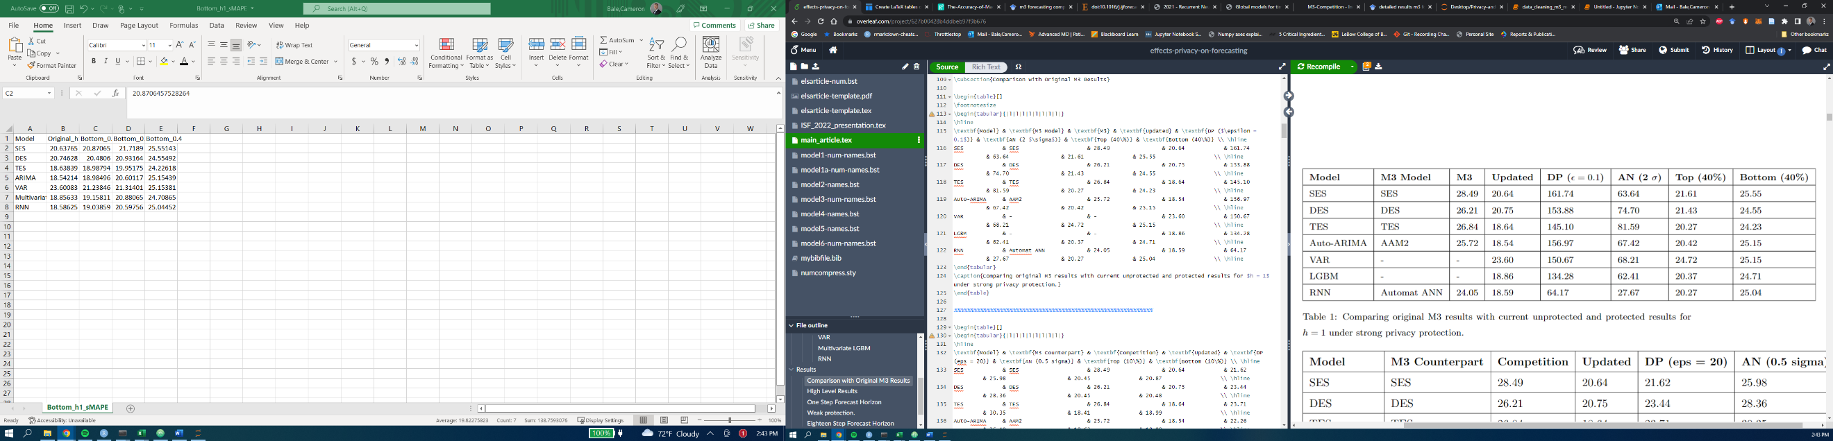

* 1. h = 1, weak privacy protection.

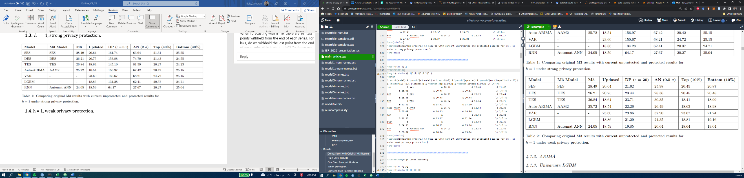

* 1. h = 18, strong privacy protection.

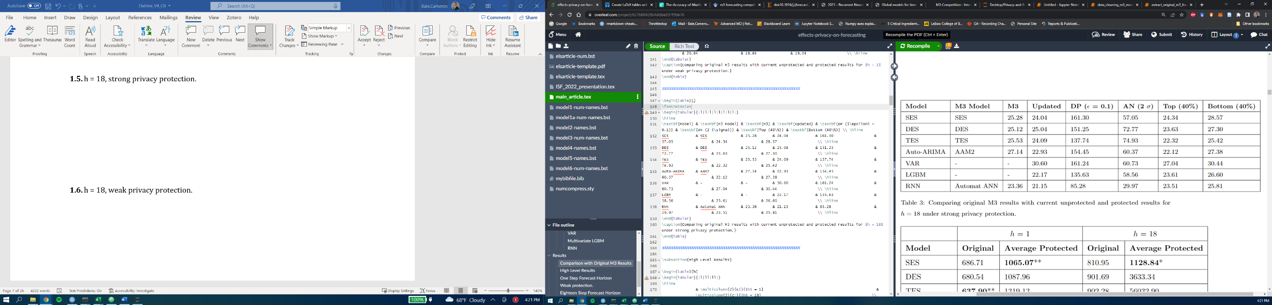

* 1. h = 18, weak privacy protection.

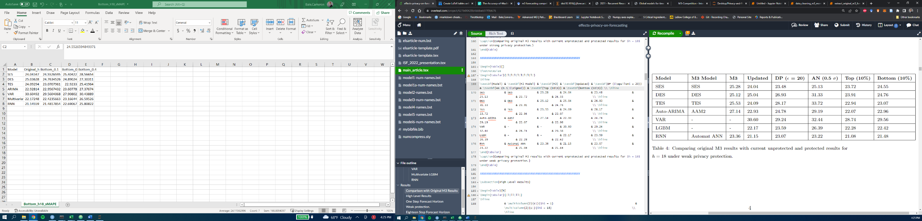

1. **High level results**
   1. i.e., if you don’t know how your data has been protected, what model should you use. Table shows original MAE and MAE averaged across protection methods.

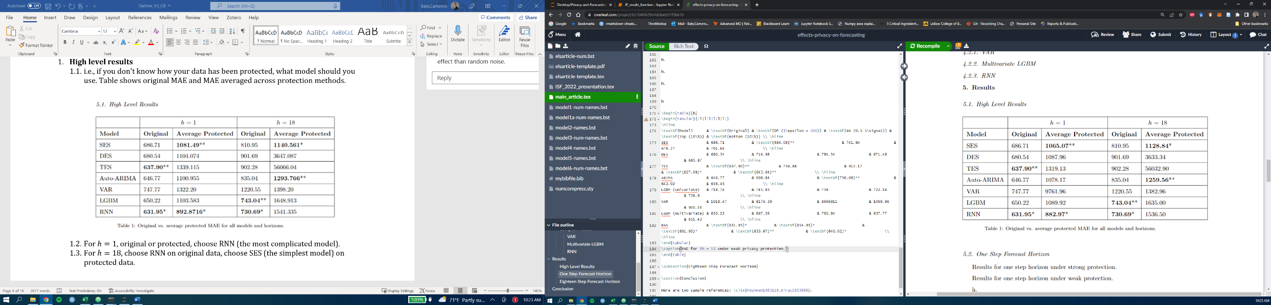

* 1. For , original or protected, choose RNN (the most complicated model).
  2. For $h=18$, choose RNN on original data, choose SES (the simplest model) on protected data.

1. **One Step Forecast Horizon.**
   1. **Strong privacy protection.**

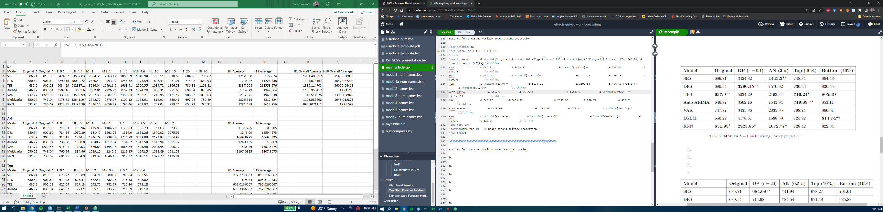

* 1. Main takeaways
     1. Protection worsens accuracy in every case.
     2. RNN is best on original data, closely followed by TES.
     3. Random noise protection:
        1. RNN is best by a large margin, followed by much simpler models taking second best (DES, SES).
     4. Top/bottom coding:
        1. TES is best, followed by auto-ARIMA (Top) and multivariate LGBM(bottom).
  2. Examining spectral entropy (forecastability) before and after data protection.
     1. Principal components are function of spectral entropy, strength of trend and seasonality, and first order autocorrelation parameter.
     2. **Component Importance.**

|  |  |  |
| --- | --- | --- |
|  | **PC1** | **PC2** |
| **Standard Deviation** | 1.71 | 0.92 |
| **Proportion of Variance** | 0.73 | 0.21 |
| **Cumulative Proportion** | 0.73 | 0.94 |

* + 1. First two components capture 94% of the total variation. Focus on the first two components. Loadings below. Note that high entropy is bad for forecastability and moves to negative values on PC1, whereas factors that are helpful for forecastability (trend, seasonal, AC) move in the positive direction.
    2. PC2 is largely driven by strength of seasonality – strong values lead to negative values for PC2. Not much contribution from entropy on PC2.

|  |  |  |
| --- | --- | --- |
|  | **PC1** | **PC2** |
| Spectral Entropy | -0.54 | -0.09 |
| Trend Strength | 0.55 | 0.29 |
| Seasonal Strength | 0.29 | -0.94 |
| AC(1) | 0.56 | 0.12 |

* + 1. Plot time series characteristics projected onto PC1 and PC2. Color points based on spectral entropy (lower=darker) is better. Solid points are protected data, hollow points with a plus in the middle are the original data.
       1. **A** – differential privacy. Most protected points cluster around the (-2, 0) area. Implies high entropy and low strength of trend/seasonality/autocorrelation.
       2. **B –** additive noise. Similar to 3.1.
       3. **C/D** – top/bottom coding. Not a large change in the projection, for top coding we see some series move slightly higher on the PC2 axis which is driven by changes in trend, seasonality, AC, which we will examine later.

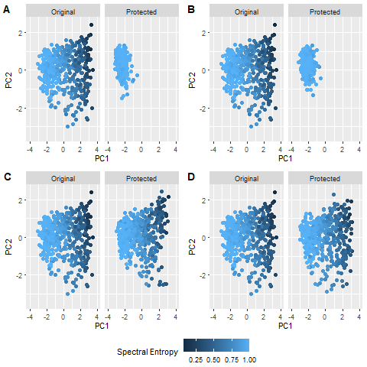

* 1. Distributions of time series characteristics.
     1. Strong protection – see plot below.

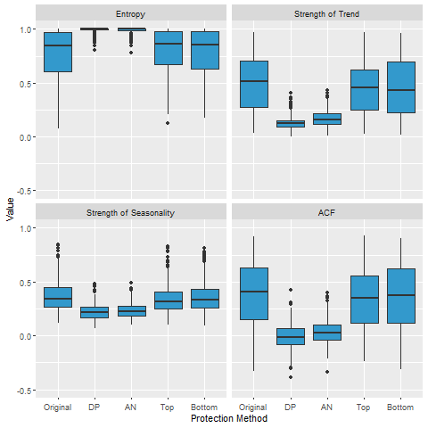

* + 1. On average for random noise protection, entropy increases, strength of trend and seasonality decrease, and most ACF values are near zero. Based on one-way ANOVA, the differences in means between the original features and the random noise protected features are all highly significant (p < 0.001).
    2. On average, top coding produces slightly higher entropy values (difference of 0.03, p = 0.03), slightly lower trend strength (difference of 0.04, p=0.006), slightly lower seasonality strength (difference of 0.02, p = 0.0008), and slightly lower ACF (difference of 0.04, p = 0.01) based on one-way ANOVAs.
    3. On average, bottom coding produces no statistically significant difference in entropy values (difference of 0.02, p = 0.30), slightly lower trend strength (difference of 0.04, p=0.01), no statistically significant difference in seasonality strength (difference of 0.01, p = 0.34), and no statistically significant difference in ACF (difference of 0.02, p = 0.47) based on one-way ANOVAs.
    4. Takeaways
       1. *Entropy.* Random noise protection destroys forecastability – most entropy values are all close to 1. Distributions of entropy between top and bottom coding and original data are similar, while average entropy is slightly higher under top coding.
       2. *Strength of trend.* Random noise protection significantly reduces the strength of the trend. Slight reductions in average trend strength from top and bottom coding.
       3. *Strength of Seasonality.* Random noise protection significantly reduces seasonality strength, average seasonality strength is slightly lower under top coding.
       4. *ACF.* Random noise protection has strong effect on ACF – the distributions have much lower variance and are centered on zero. Top coding produces a slight reduction in average ACF.
    5. **Accuracy Breakdown by Adjustment Direction and size**
       1. Differential Privacy table. Shows the proportion of forecasts that were adjusted either positively or negatively, and the average adjustment magnitude and % improvement to MAE (negative is worse accuracy, positive is better accuracy) broken down by adjustment direction and model.

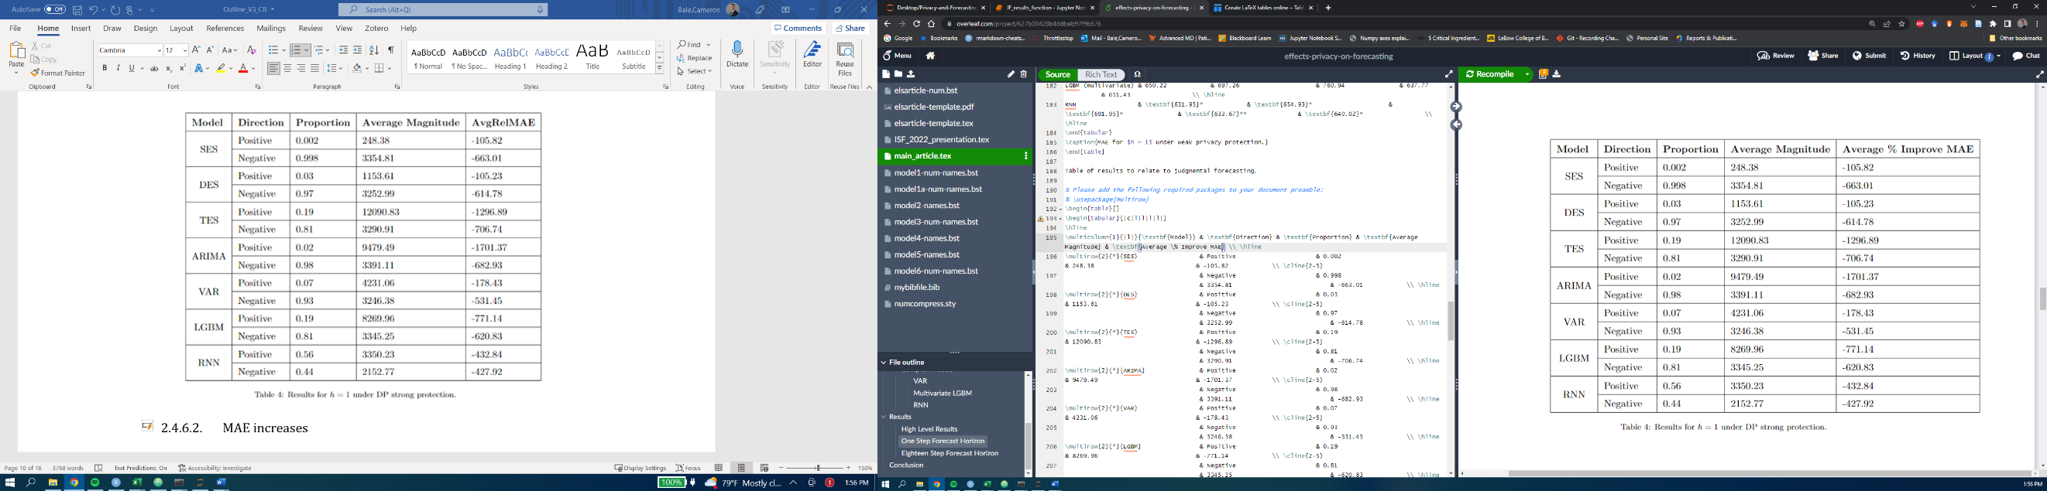

* + - 1. MAE increases regardless of direction and model. RNN sees balanced reduction in MAE across directions, in contrast to TES which sees extremely large reductions for large upward adjusted forecasts (average magnitude of over 12,000) – suggests that TES is trying to fit to the noise, rather than “smooth” it out. Compare to SES and DES, which have larger negative adjustments.
    1. Additive noise table.

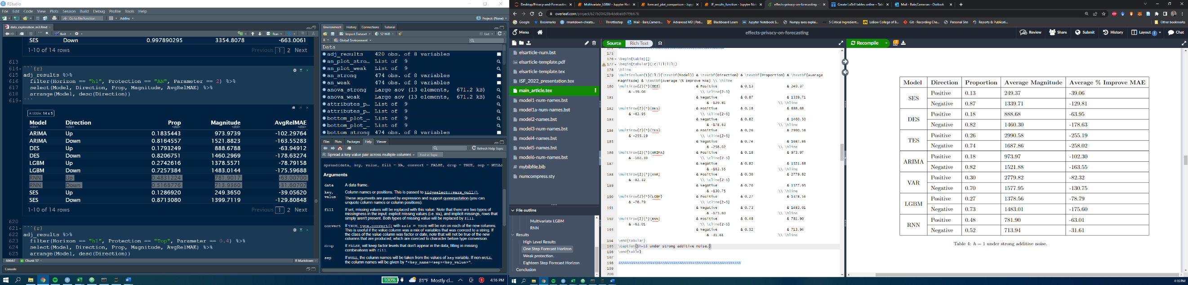

* + - 1. Takeaways: MAE increases across the board. There is a higher proportion of negative adjusted forecasts. These have larger magnitude for SES and DES, which contrasts with TES and VAR which have much larger positive adjustments and much worse accuracy. RNN has the best accuracy, and has similar magnitude positive and negative adjustments, with positive adjustments producing a higher percentage increase in MAE.
      2. Top coding table.

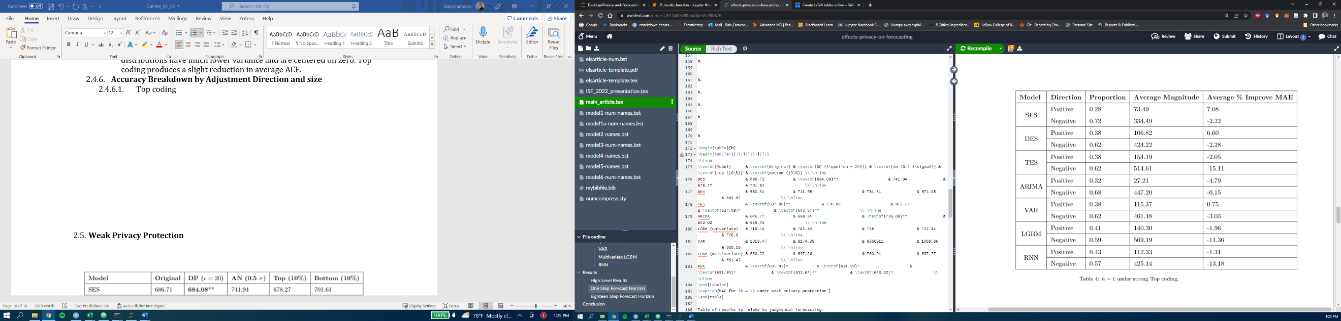

* + - 1. Takeaways: most forecasts are adjusted negatively, and negative adjustments have a larger average magnitude. Negative adjustments result in increase in MAE on average for all models. Positive adjustments result in reduced MAE for some models, but proportion of positively adjusted forecasts is small.
      2. Bottom coding table.

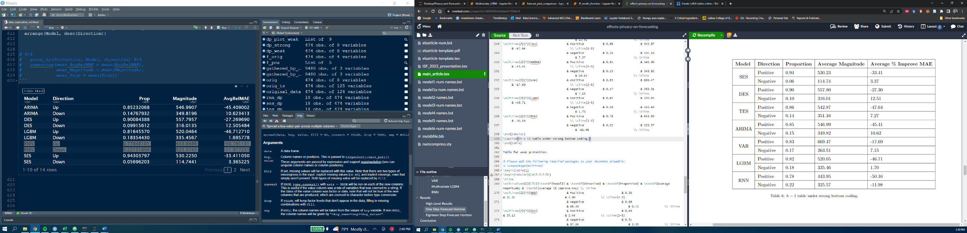

* + - 1. Takeaways: most forecasts are adjusted positively with increases in MAE, and magnitude of positive adjustments is larger. Negatively adjusted forecasts for all models except RNN see improvements in MAE.
  1. **Weak Privacy Protection**

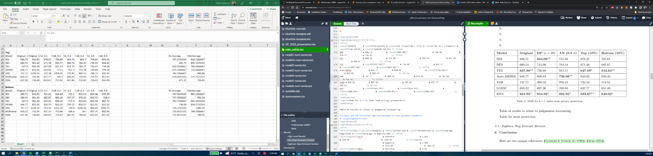

* 1. Main takeaways:
     1. There are a few accuracy improvements – top coding improves accuracy for all except RNN. VAR improves under bottom coding. TES under top coding produces the best overall accuracy for $h=1.$
     2. Random noise protection:
        1. RNN is best, followed by much simpler models taking second best (ARIMA, SES).
     3. Top/bottom coding:
        1. TES and RNN are best.
  2. Spectral entropy plots under weak protection.
     1. **A –** differential privacy.
     2. **B** – additive noise
     3. **C** – top coding
     4. **D –** bottom coding
     5. Weak random noise protection tends to squeeze points towards zero on both component axes, and increases entropy, as seen in later plot. Not many visual differences for top and bottom coding.

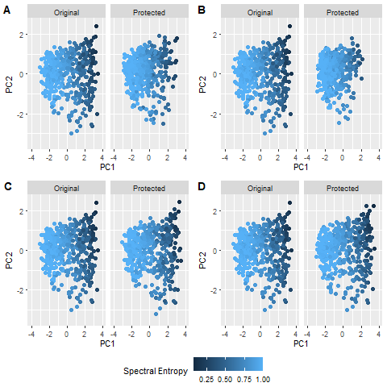

* + 1. Weak Protection. See plot below.

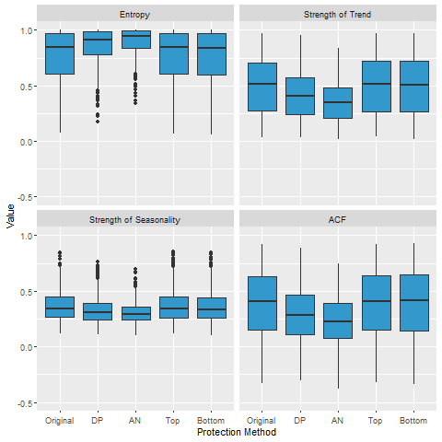

* + 1. On average for random noise protection, entropy increases, strength of trend and seasonality decrease, and most ACF values are near zero. Based on one-way ANOVA, the differences in means between the original features and the random noise protected features are all highly significant (p < 0.001).
    2. There are no statistically significant differences between the mean characteristics of the original data and the top and bottom coded data.
    3. Takeaways.
       1. Same as under strong protection for random noise protection, but less severe changes.
    4. **Accuracy Breakdown by Adjustment Direction and size**
       1. *Differential Privacy table.*

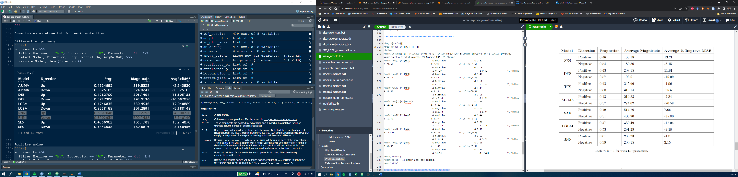

* + - 1. Takeaways: kind of interesting results here – SES and RNN perform the best MAE-wise, but have very different forecast adjustments. For positive adjusted forecasts, SES has a large reduction in MAE, whereas RNN sees an increase. The opposite occurs for negatively adjusted forecasts.
      2. *Additive Noise table.*

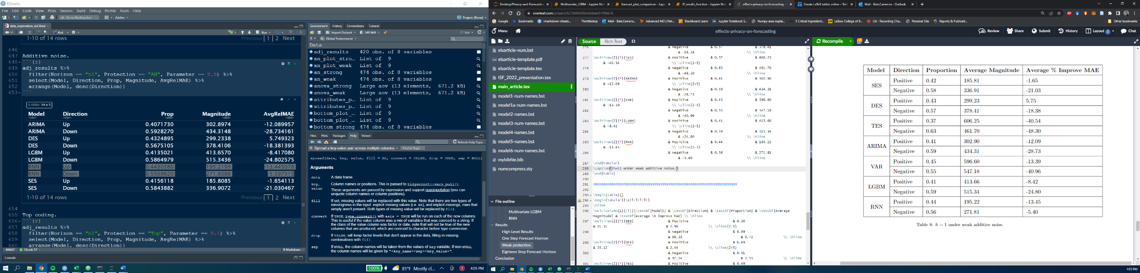

* + - 1. Takeaways: increased error across the board except for positive adjusted forecasts under DES. RNN and Auto-ARIMA did the best here (closely followed by SES). (not really getting anything meaningful that I can see beyond that).
      2. *Top coding table.*

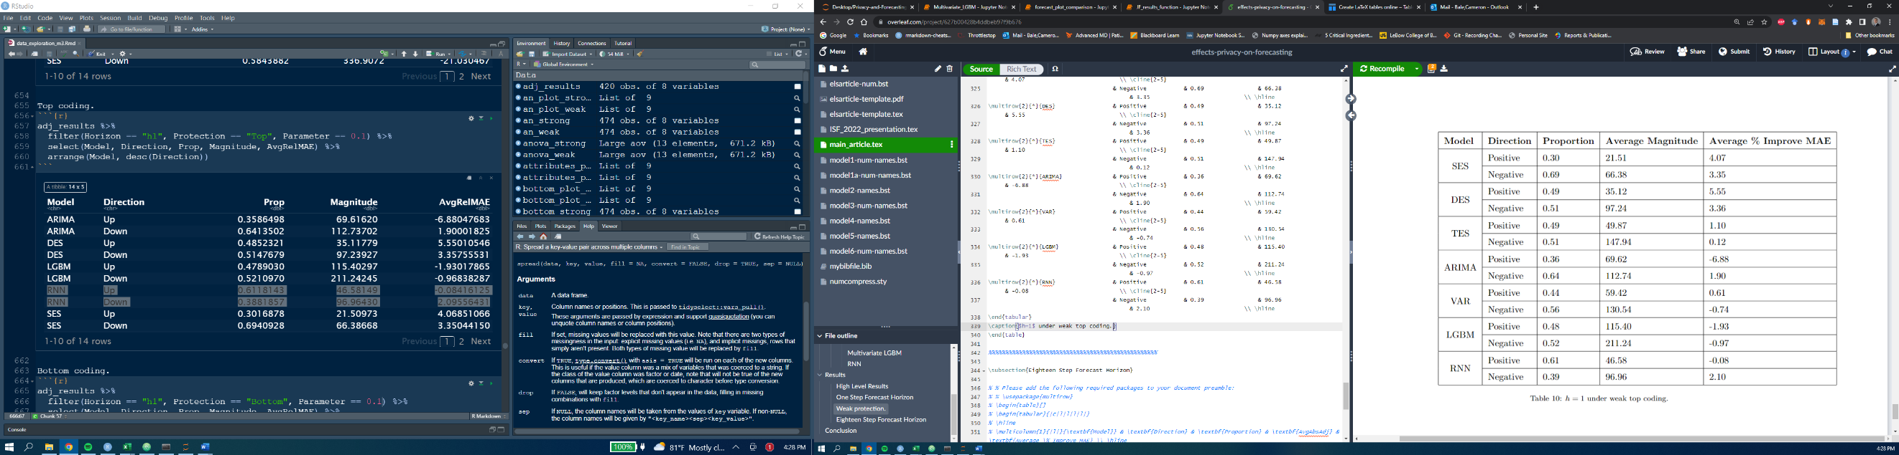

* + - 1. Takeaways: There is a higher proportion of negative adjusted forecasts for all models except RNN. The magnitudes of negative adjustments are larger than positive adjustments. Negative and positive adjustments improve average accuracy for SES, DES, TES, but there is not a consistent pattern for the rest of the models.
      2. *Bottom coding table.*

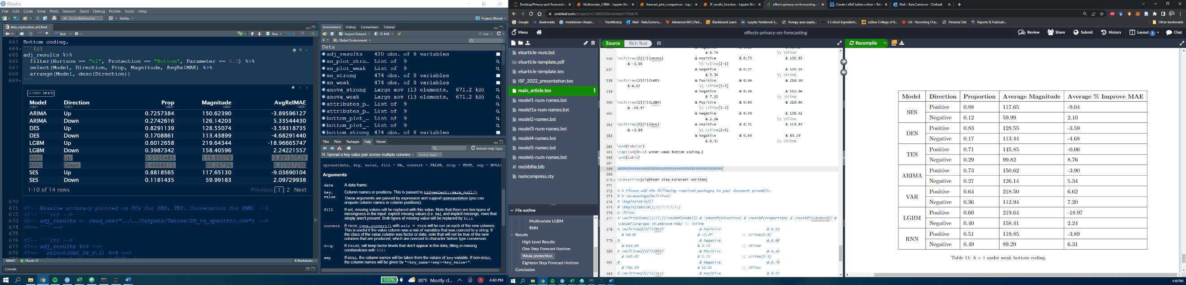

* + - 1. A higher proportion of positive adjustments are made, and positive adjustments have larger magnitude on average. These positive adjustments hurt accuracy for all models except VAR, whereas negative adjustments improve accuracy for all models except DES.
  1. **18-step horizon**
     1. **Strong Privacy protection**

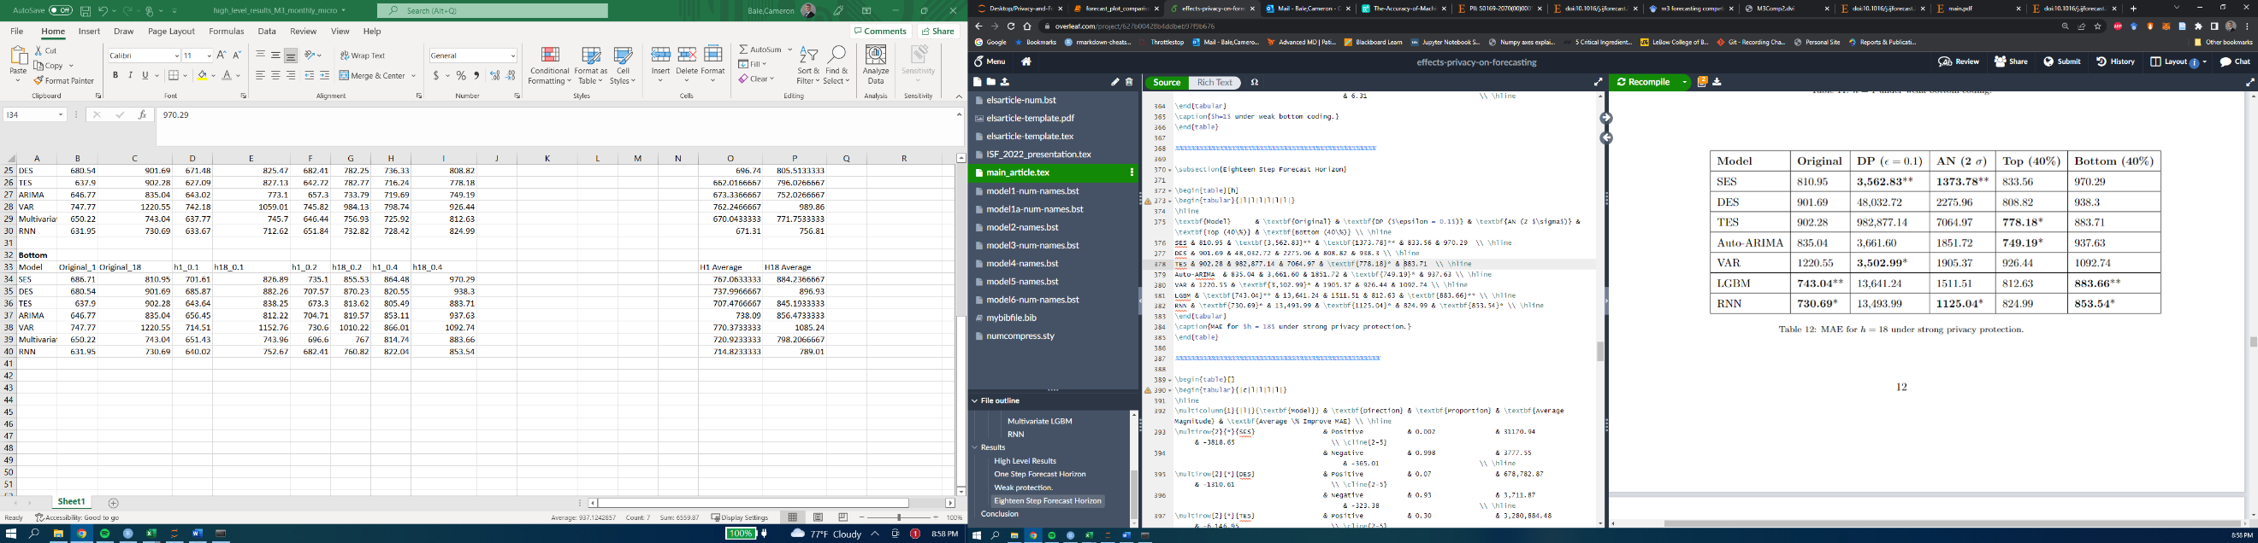

* + 1. **Accuracy breakdown by adjustment direction and size**
       1. Differential privacy table.

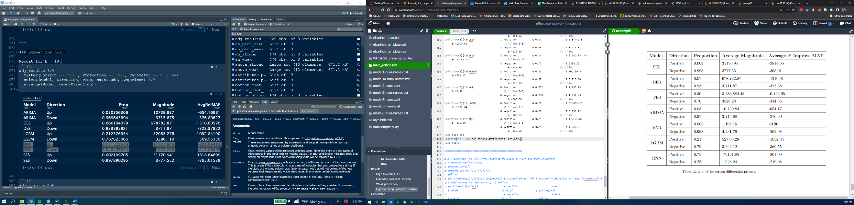

* + - 1. Additive noise table.

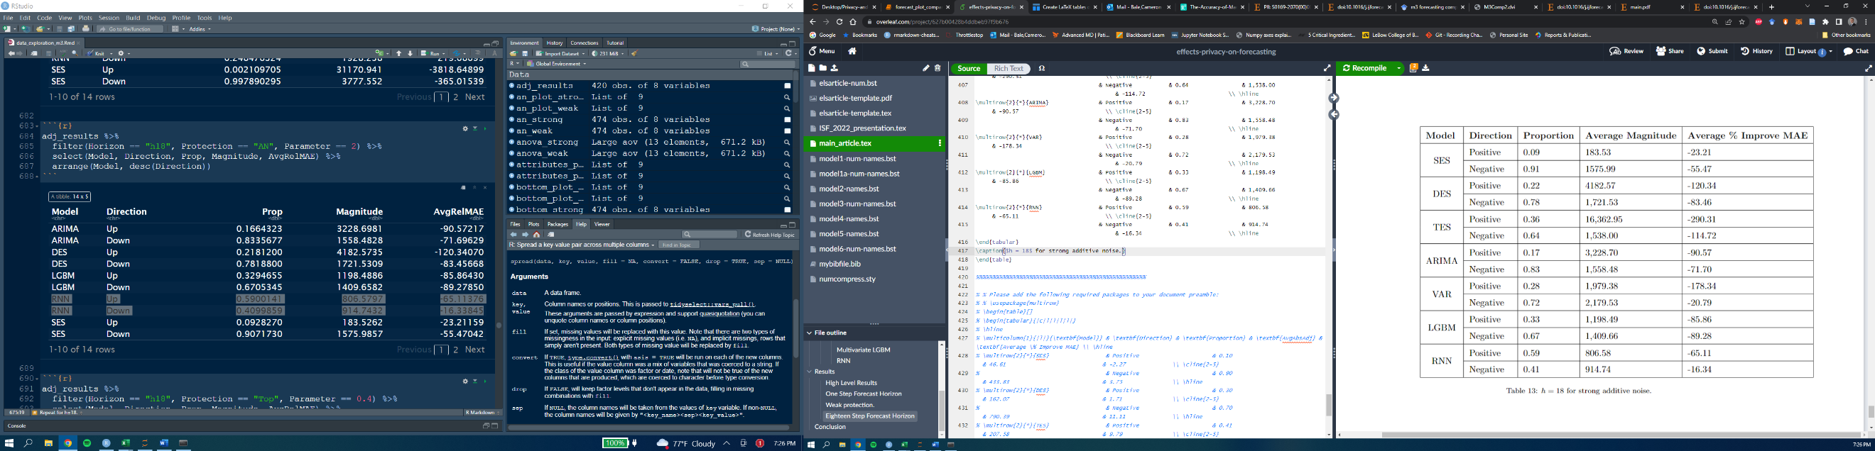

* + - 1. Top coding table.

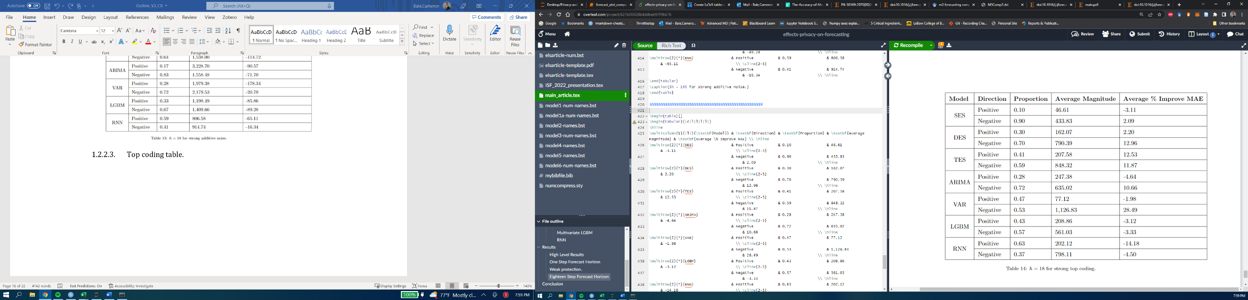

* + - 1. 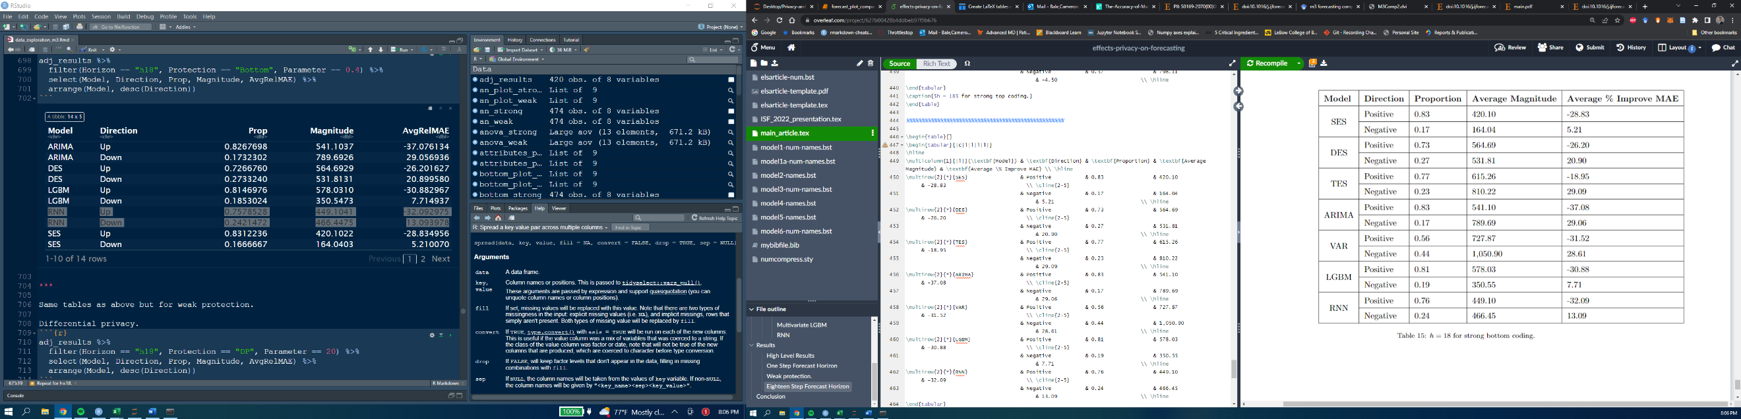Bottom coding table.
    1. This one looks really good for the judgmental forecasting story.
    2. **Weak Privacy protection**

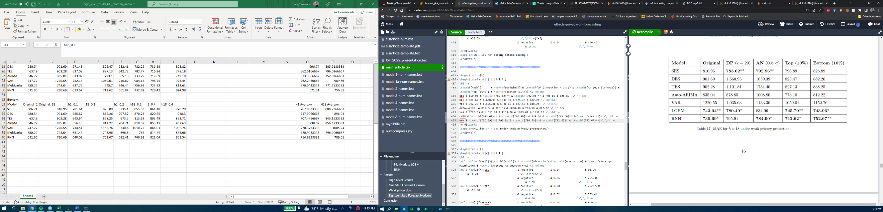

* + 1. **Accuracy breakdown by adjustment direction and size**
       1. Differential privacy table.

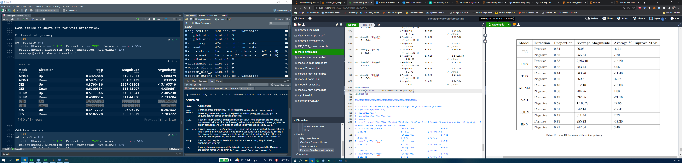

* + - 1. Additive noise table.

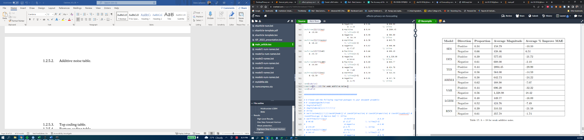

* + - 1. Top coding table.

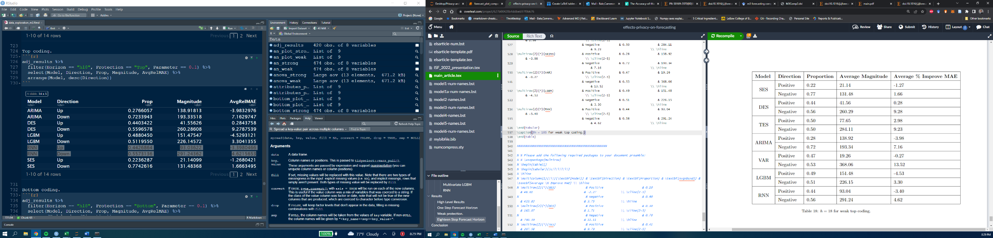

* + - 1. Bottom coding table.

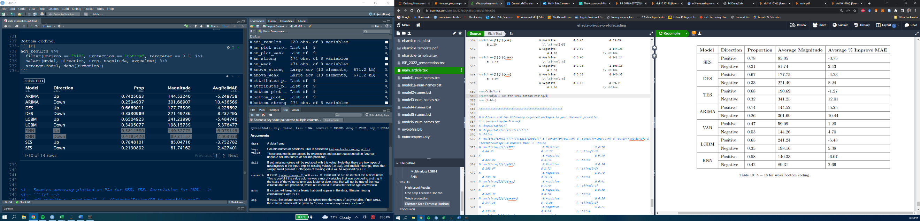

Two-sided binomial test for the probability of an adjustment that increases accuracy – use similar table as below (Davydenko & Fildes, 2013).



**Conclusions (incomplete)**

1. General Discussion
   1. Which models performed best on original data.
      1. Why.
   2. Which models performed best on protected data.
      1. Why.
2. Managerial Implications
   1. Limit analysts to simple models when forecasting using protected data.
3. Future Work
   1. Ways to improve forecast accuracy under data protection.
      1. Make adjustments based on methods from judgmental forecasting literature (Fildes et al., 2009)

Like forecasting support systems that actively evaluate and filter information before presenting it (Fildes et al., 2019), design (or implement) methods to filter random noise from the series prior to forecasting.

**References**

IAPP, 2020. US State Privacy Legislation Tracker. <https://iapp.org/resources/article/us-state-privacy-legislation-tracker/>.

Abowd, J. M., Gittings, K., McKinney, K. L., Stephens, B. E., Vilhuber, L., & Woodcock, S. (2012). *Dynamically consistent noise infusion and partially synthetic data as confidentiality protection measures for related time-series*. 41.

Boone, T., Ganeshan, R., Jain, A., & Sanders, N. R. (2019). Forecasting sales in the supply chain: Consumer analytics in the big data era. *International Journal of Forecasting*, *35*(1), 170–180. https://doi.org/10.1016/j.ijforecast.2018.09.003

Chen, C., & Liu, L.-M. (1993). Forecasting time series with outliers. *Journal of Forecasting*, *12*(1), 13–35. https://doi.org/10.1002/for.3980120103

Crimi, N., & Eddy, W. (2014). Top-Coding and Public Use Microdata Samples from the U.S. Census Bureau. *Journal of Privacy and Confidentiality*, *6*(2). https://doi.org/10.29012/jpc.v6i2.639

Davydenko, A., & Fildes, R. (2013). Measuring forecasting accuracy: The case of judgmental adjustments to SKU-level demand forecasts. *International Journal of Forecasting*, *29*(3), 510–522. https://doi.org/10.1016/j.ijforecast.2012.09.002

Fildes, R., Goodwin, P., Lawrence, M., & Nikolopoulos, K. (2009). Effective forecasting and judgmental adjustments: An empirical evaluation and strategies for improvement in supply-chain planning. *International Journal of Forecasting*, *25*(1), 3–23. https://doi.org/10.1016/j.ijforecast.2008.11.010

Fildes, R., Goodwin, P., & Önkal, D. (2019). Use and misuse of information in supply chain forecasting of promotion effects. *International Journal of Forecasting*, *35*(1), 144–156. https://doi.org/10.1016/j.ijforecast.2017.12.006

Gonçalves, C., Bessa, R. J., & Pinson, P. (2021). A critical overview of privacy-preserving approaches for collaborative forecasting. *International Journal of Forecasting*, *37*(1), 322–342. https://doi.org/10.1016/j.ijforecast.2020.06.003

Goncalves, C., Pinson, P., & Bessa, R. J. (2021). Towards Data Markets in Renewable Energy Forecasting. *IEEE Transactions on Sustainable Energy*, *12*(1), 533–542. https://doi.org/10.1109/TSTE.2020.3009615

Hewamalage, H., Bergmeir, C., & Bandara, K. (2021). Recurrent Neural Networks for Time Series Forecasting: Current status and future directions. *International Journal of Forecasting*, *37*(1), 388–427. https://doi.org/10.1016/j.ijforecast.2020.06.008

Hewamalage, H., Bergmeir, C., & Bandara, K. (2022). Global models for time series forecasting: A Simulation study. *Pattern Recognition*, *124*, 108441. https://doi.org/10.1016/j.patcog.2021.108441

Imtiaz, S., Horchidan, S.-F., Abbas, Z., Arsalan, M., Chaudhry, H. N., & Vlassov, V. (2020). Privacy Preserving Time-Series Forecasting of User Health Data Streams. *2020 IEEE International Conference on Big Data (Big Data)*, 3428–3437. https://doi.org/10.1109/BigData50022.2020.9378186

Kang, Y., Hyndman, R. J., & Smith-Miles, K. (2017). Visualising forecasting algorithm performance using time series instance spaces. *International Journal of Forecasting*, *33*(2), 345–358. https://doi.org/10.1016/j.ijforecast.2016.09.004

Liyue Fan & Li Xiong. (2014). An Adaptive Approach to Real-Time Aggregate Monitoring With Differential Privacy. *IEEE Transactions on Knowledge and Data Engineering*, *26*(9), 2094–2106. https://doi.org/10.1109/TKDE.2013.96

Luo, J., Hong, T., & Fang, S.-C. (2018). Benchmarking robustness of load forecasting models under data integrity attacks. *International Journal of Forecasting*, *34*(1), 89–104. https://doi.org/10.1016/j.ijforecast.2017.08.004

Makridakis, S., & Hibon, M. (2000). The M3-Competition: Results, conclusions and implications. *International Journal of Forecasting*, *16*(4), 451–476. https://doi.org/10.1016/S0169-2070(00)00057-1

Nin, J., & Torra, V. (2009). Towards the evaluation of time series protection methods. *Information Sciences*, *179*(11), 1663–1677. https://doi.org/10.1016/j.ins.2009.01.024

Sweeney, L. (2002). k-ANONYMITY: A MODEL FOR PROTECTING PRIVACY. *International Journal of Uncertainty, Fuzziness and Knowledge-Based Systems*, *10*(05), 557–570. https://doi.org/10.1142/S0218488502001648

Wellens, A. P., Udenio, M., & Boute, R. N. (2021). Transfer learning for hierarchical forecasting: Reducing computational efforts of M5 winning methods. *International Journal of Forecasting*, S0169207021001606. https://doi.org/10.1016/j.ijforecast.2021.09.011